Wireshark Lab 1: Ethernet and ARP

Group Details: Rushab Roihan #1003945289

Mark:

 | Question | Answer
1 | What is the 48-bit Ethernet address of your computer? | The Ethernet address is 00:d0:59:a9:3d:68
2 | What is the 48-bit destination address in the Ethernet frame?  What device has this as its  Ethernet address? | The 48-bit destination address is 00:06:25:da:af:73. This is the address of  the router which is the link that is used to get off the subnet.  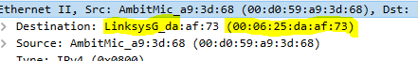
3 | Give the hexadecimal value for the two-byte Frame type field.  What upper layer protocol does this correspond to? | The hex value for the Frame type field is (0x0800). This corresponds to the IP protocol (IPv4) which is the frame type indicating the next layer above IP which is the layer to which the payload of the Ethernet frame will be passed on to.  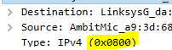
4 | How many bytes from the very start of the Ethernet frame does the ASCII “G” in “GET” appear in the Ethernet frame? | The ASCII “ G” appears 52 bytes from start of frame  14 B Ethernet Frame->20 bytes of IP header -> 20 bytes of TCP header.  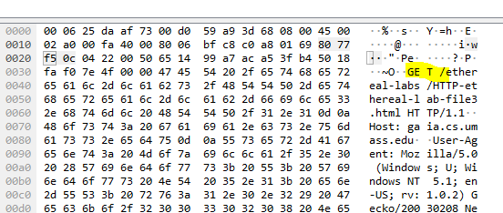
5 | What is the value of the Ethernet source address?  What device has this as its Ethernet address? | It is 00:d0:59:a9:3d:68  This is the address of the router it is connected to
6 | What is the destination address in the Ethernet frame?  Is this the Ethernet address of your computer? | The address is 00:06:25:da:af:73  It is the Ethernet address of the router  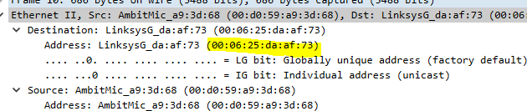
7 | Give the hexadecimal value for the two-byte Frame type field.  What upper layer protocol does this correspond to? | Same as Q3),  0x0800 corresponding to an IPv4 frame.
8 | How many bytes from the very start of the Ethernet frame does the ASCII “O” in “OK” (i.e., the HTTP response code) appear in the Ethernet frame? | 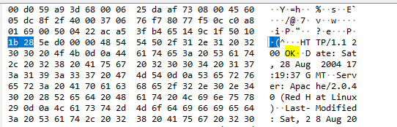  There are 67 bytes before the “O” as “O” appears at the 68th byte. These bytes include ehternet frame, IP header, TCP header, and HTTP preamble text
9 | Write down the contents of your computer’s ARP cache.  What is the meaning of each column value? | 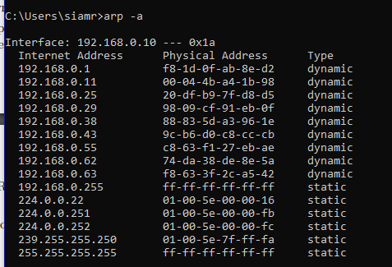  The columns show the ip address (IPv4) and the physical address (Ethernet). The last column shows if IPv4 is either static or dynamic
10 | What are the hexadecimal values for the source and destination addresses in the Ethernet frame containing the ARP request message? | The source address: 00:80:ad:73:8d:ce  Destination Address ff:ff:ff:ff:ff:ff  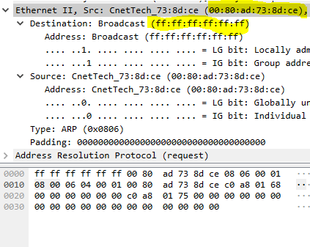
11 | Give the hexadecimal value for the two-byte Ethernet Frame type field.  What upper layer protocol does this correspond to? | It is 0x0806 and this corresponds to ARP  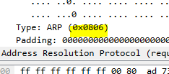
12 | -
13 | -
14 | What are the hexadecimal values for the source and destination addresses in the Ethernet frame containing the ARP reply message? | Source: 00:06:25:da:af:73  Destination: 00:d0:59:a9:3d:68  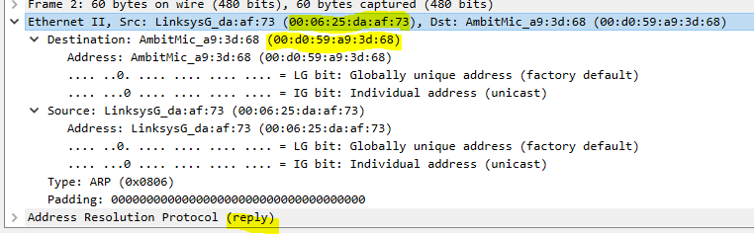
15 | -

